Лабораторна робота № 2

**Приклади**

using System;

namespace Task1

{

class Program

{

private const int x = 3;

private const int y = 3;

private static void InputArray(int[,] array)

{

Console.WriteLine("Input massive with size {x}x{y}");

for (int i = 0; i < array.GetLength(0); i++)

for (int j = 0; j < array.GetLength(1); j++)

array[i, j] = Int32.Parse(Console.ReadLine());

}

static void PrintArray(string a, int[,] mas)

{

Console.WriteLine(a);

for (int i = 0; i < mas.GetLength(0); i++)

{

for (int j = 0; j < mas.GetLength(1); j++) Console.Write("{0} ", mas[i, j]);

Console.WriteLine();

}

}

static int Change(int[,] mas)

{

int res = 0;

for (int i = 0; i < mas.GetLength(0); i++)

for (int j = 0; j < mas.GetLength(1); j++)

if (mas[i, j] % 2 == 0) res += mas[i, j];

return res;

}

public static void Main()

{

try

{

int[,] myArray = new int[x, y];

InputArray(myArray);

PrintArray("вихідний масив:", myArray);

int res = Change(myArray);

Console.WriteLine($"Сума непарних = {res}");

}

catch (FormatException)

{

Console.WriteLine("невірний формат вводу даних");

}

catch (OverflowException)

{

Console.WriteLine("переповнення");

}

catch (OutOfMemoryException)

{

Console.WriteLine("недостатньо пам'яті для створення нового об'єкта");

}

}

}

}

**2**

using System;

namespace Arrays

{

class Program

{

static void Main()

{

try

{

int[][] MyArray;

Console.Write("Input count of rows: ");

int n = int.Parse(Console.ReadLine());

MyArray = new int[n][];

for (int i = 0; i < MyArray.Length; i++)

{

Console.WriteLine($"Input count of elements in {i} row");

int j = int.Parse(Console.ReadLine());

MyArray[i] = new int[j];

for (j = 0; j < MyArray[i].Length; j++)

{

Console.Write("a[{0}][{1}]= ", i, j);

MyArray[i][j] = int.Parse(Console.ReadLine());

}

}

PrintArray("output array:", MyArray);

for (int i = 0; i < MyArray.Length; i++)

Array.Sort(MyArray[i]);

PrintArray("updated array:", MyArray);

}

catch (FormatException)

{

Console.WriteLine("Invalid format of date");

}

catch (OverflowException)

{

Console.WriteLine("OverFlow");

}

catch (OutOfMemoryException)

{

Console.WriteLine("OutOfMemory");

}

}

static void PrintArray(string a, int[][] mas)

{

Console.WriteLine(a);

for (int i = 0; i < mas.Length; i++)

{

for (int j = 0; j < mas[i].Length; j++)

Console.Write("{0} " mas[i][j]);

Console.WriteLine();

}

}

}

}

**Завдання 1**



using System;

namespace Project_1

{

internal class Lab_2_1

{

public static void Main(string[] args) {

int rows, columns;

double[,] matrix;

double[] vector;

double[] result;

Console.WriteLine("How many rows : ");

rows = Convert.ToInt32(Console.ReadLine());

Console.WriteLine("How many columns : ");

columns = Convert.ToInt32(Console.ReadLine());

matrix = new double[rows, columns];

vector = new double[columns];

result = new double[rows];

Console.WriteLine("\n___Matrix___");

for (int i = 0; i < rows; i++) {

for (int j = 0; j < columns; j++) {

Console.WriteLine("Matrix [{0}][{1}] = ", i, j);

matrix[i, j] = Convert.ToDouble(Console.ReadLine());

}

}

Console.WriteLine("\n___Vector___");

for (int i = 0; i < columns; i++) {

Console.WriteLine("Vector [{0}] = ", i);

vector[i] = Convert.ToDouble(Console.ReadLine());

}

for (int i = 0; i < rows; i++) {

result[i] = 0;

for (int j = 0; j < columns; j++) {

result[i] += matrix[i, j] * vector[j];

}

}

Console.WriteLine("\n__Matrix__");

for (int i = 0; i < rows; i++) {

for (int j = 0; j < columns; j++) {

Console.Write("{0}\t", matrix[i, j]);

}

Console.Write("\n");

}

Console.WriteLine("\n__Vector__");

for (int i = 0; i < columns; i++) {

Console.Write("{0}\t", vector[i]);

}

Console.WriteLine("\n\n__Result (Matrix * Vector) __");

for (int i = 0; i < rows; i++) {

Console.Write("{0}\t", result[i]);

}

}

}

}

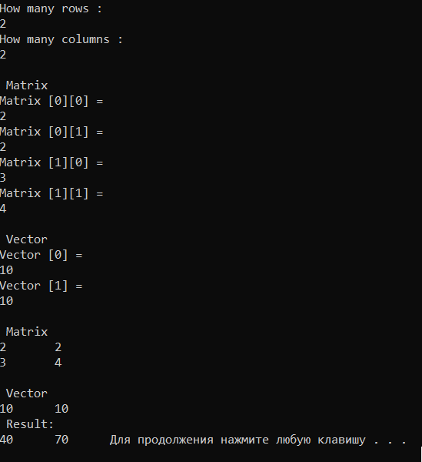

**Завдання 2**

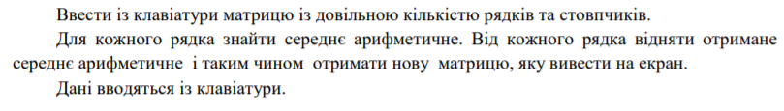

using System;

using System.Collections.Generic;

using System.Linq;

using System.Text;

using System.Threading.Tasks;

namespace Task2

{

class Matr

{

static void PrintArray (string a, double[,] mas)

{

Console.WriteLine(a);

for(int i=0; i<mas.GetLength(0); i++)

{

for (int j = 0; j < mas.GetLength(1); j++)

Console.Write("{0}", mas[i, j]);

Console.WriteLine();

}

}

static void Main()

{

double[] average = { 0, 0, 0 };

double[,] matr = new double[2, 2];

Console.WriteLine("Input elements of Matr [2,2]");

for (int i = 0; i < 2; i++)

for (int j = 0; j < 2; j++)

matr[i, j] = double.Parse(Console.ReadLine());

for (int i = 0; i < 2; i++)

for (int j = 0; j < 2; j++)

average[i] += matr[i, j];

for (int i=0; i<2; i++)

{

//try

//{

// average[i] = average[i] / 3;

//}

//catch (DivideByZeroException e)

//{

// Console.WriteLine(e.Message);

//}

average[i] = average[i] / 2;

for (int j = 0; j < 2; j++)

matr[i, j] = matr[i, j] - average[i];

}

PrintArray("Result: ", matr);

Console.ReadKey();

}

}

}

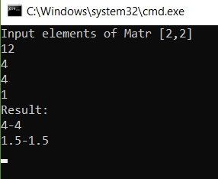

**Індивідуальне завдання згідно варіанту**



using System;

using System.Collections.Generic;

using System.Linq;

using System.Text;

using System.Threading.Tasks;

namespace task2

{

class Class

{

static int[] Input()

{

Console.WriteLine("Size of Massive:");

int n = int.Parse(Console.ReadLine());

int[] a = new int[n];

for(int i=0; i<n; i++)

{

Console.Write("a[{0}]=", i);

a[i] = int.Parse(Console.ReadLine());

}

return a;

}

static void Print (int [] a, int n)

{

for(int i=0; i<n; i++)

{

Console.Write("{0}", a[i]);

Console.WriteLine();

}

}

static int FindMaxNegative(int[] a, int n)

{

int ind = -1;

int max = -9999999;

for(int i=0; i<n; i++)

{

if(a[i]<0 && a[i]>=max)

{

ind = i;

max = a[i];

}

}

return ind;

}

static int FindMin(int []a, int n)

{

int min = a[0];

int ind = 0;

for(int i=0; i<n; i++)

{

if(a[i]<min)

{

min = a[i];

ind = i;

}

}

return ind;

}

static void GetResultArray(int[] source, int[] target, int start, int finish)

{

target[0] = source[start];

target[target.Length - 1] = source[finish];

for (int i = start + 1, j = target.Length - 2; i < finish; i++, j--)

{

target[j] = source[i];

}

}

static void Main()

{

int[] myArray = Input();

int n = myArray.Length;

Print(myArray, n);

int first = FindMaxNegative(myArray, n);

if(first==-1)

{

Console.WriteLine("Array doesn`t have enough negative elements");

Environment.Exit(0);

}

int second = FindMin(myArray, n);

int start = Math.Min(first, second);

int finish = Math.Max(first, second);

Console.WriteLine(start + " " + finish);

int[] result = new int[finish - start + 1];

GetResultArray(myArray, result, start, finish);

Console.WriteLine("Result massive:");

Print(result, result.Length);

}

}

}

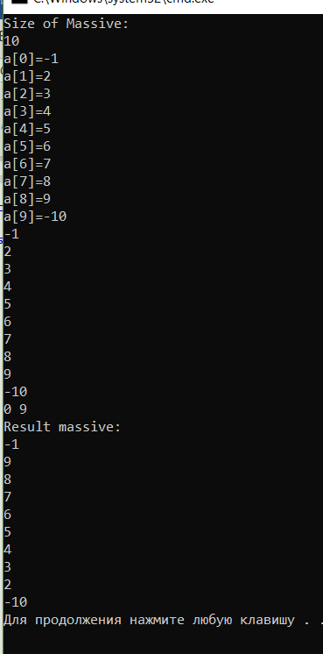

**Завдання 3**

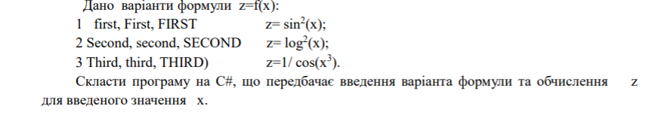

using System;

namespace Arrays

{

class Program

{

static void Main(string[] args)

{

string variant, s;

double x, z;

Console.WriteLine("Enter x=");

s = Console.ReadLine();

x = Convert.ToDouble(s);

while (true)

{

Console.WriteLine("Enter first, second or third");

variant = Console.ReadLine();

switch (variant)

{

case "first":

case "First":

case "FIRST":

z = Math.Sin(x) * Math.Sin(x);

Console.WriteLine("z=Sin(x)^2={0}", z);

break;

case "second":

case "Second":

case "SECOND":

z = Math.Pow(Math.Log(x), 2);

Console.WriteLine("z={0}", z);

break;

case "third":

case "Third":

case "THIRD":

z = 1 / Math.Cos(x * x * x);

Console.WriteLine("z={0}", z);

break;

default:

Console.WriteLine("Wrong variant");

break;

case "end":

Environment.Exit(0);

break;

}

}

}

}

}

